- 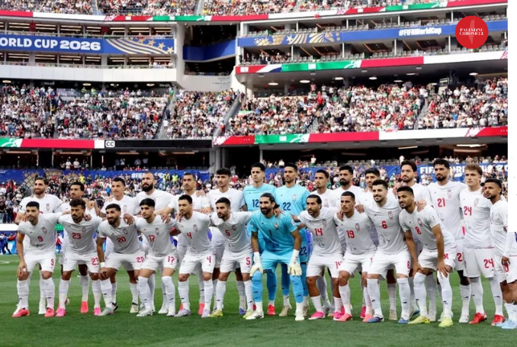The Iranian team Photo: Instagram/@teammellifootball Taken from 'Most Persecuted Team': Iran to File FIFA Complaint over World Cup Restrictions - Palestine Chronicle
Against All Odds: Iran's Defiant Stand at the 2026 World Cup

A Tournament Overshadowed by Politics by Saba T Kidane Heritage July 9, 2026
The World Cup is a time of great energy and fanfare for football fans—or as it is called in the United States, soccer. While soccer does not enjoy the same level of popularity as other American sports, the 2026 World Cup has brought unprecedented attention to the game, as it is jointly hosted by three countries: the United States, Mexico, and Canada, with matches held across 16 host cities—11 in the U.S., three in Mexico, and two in Canada.
This year's tournament, however, has been complicated by the unfair treatment of the Iranian national football team by the United States. Due to the war between the two countries, the U.S. imposed severe restrictions on the Iranian delegation. The Iranian team was forced to relocate its base from Tucson, Arizona, to Tijuana, Mexico, and had to commute across the border to play their matches in the United States. The team was only permitted to arrive 24 hours or less before each game and had to leave within hours of the final whistle, making it extremely difficult for players to get critical rest and training time due to these restrictive immigration policies imposed almost exclusively on them. Additionally, some members of the Iranian team leadership, media, and other officials were denied U.S. visas, forcing them to remain in Mexico.
One might ask how this is fair. Of course, there is nothing fair about the situation the Iranian team found themselves in. In spite of all that, however, the Iranian team gave their all on the field and showed their people and fans around the world their dedication, hard work, and dignity. As the Iranian team manager put it, "our team is the most oppressed team in this World Cup".

[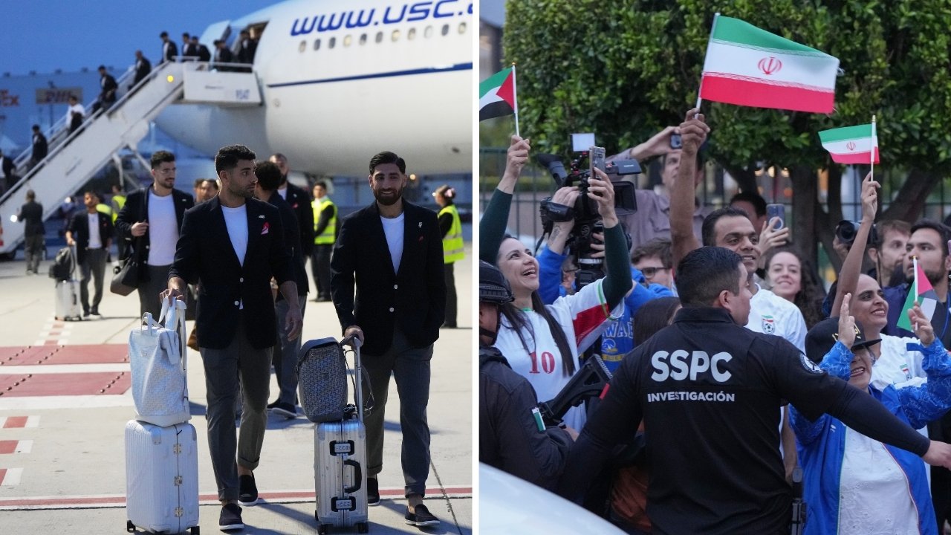
Iran's Alireza Jahanbakhsh arrives with his teammates for the World Cup soccer tournament in Tijuana, Mexico (left image) while fans wave (right image). Sunday, June 7, 2026 Copyright of 15 Iranian soccer federation members denied US visas ahead of team's World Cup opener in Los Angeles - ABC7 Los Angeles

Divided Fans, United Team
In their first game, Iran faced New Zealand at SoFi Stadium in Inglewood, California, finishing in a 2-2 draw. In their second game, they held Belgium to a 0-0 draw at the same stadium. Both matches were played in Los Angeles, home to the largest Iranian diaspora in the United States.
The reaction of the Iranian diaspora was divided: one faction booed and chanted condemnations of the Iranian government, while others showed support for the team. The booing faction, aligned with the former Shah's son, flew the flag of the Pahlavi era alongside Israeli and American flags. Some protested outside the Los Angeles stadium and turned their backs when the Iranian national anthem was played at the start of the games. It is not clear how much of this was audible or visible to the players during the matches, but they would certainly have been aware of it before and after. One can only imagine how difficult it must have been for them to navigate all of this, on top of the restrictive immigration policies of the U.S. government.

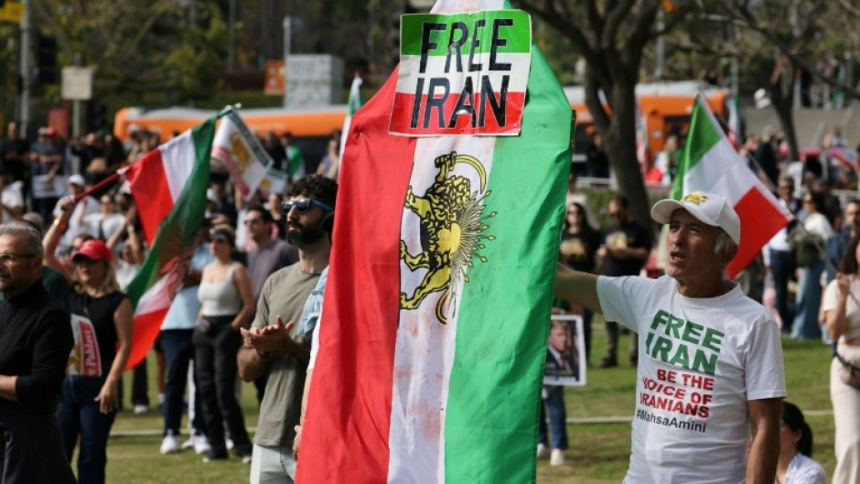
A photo showing protesters with flags of the Sha era @eNCA.com
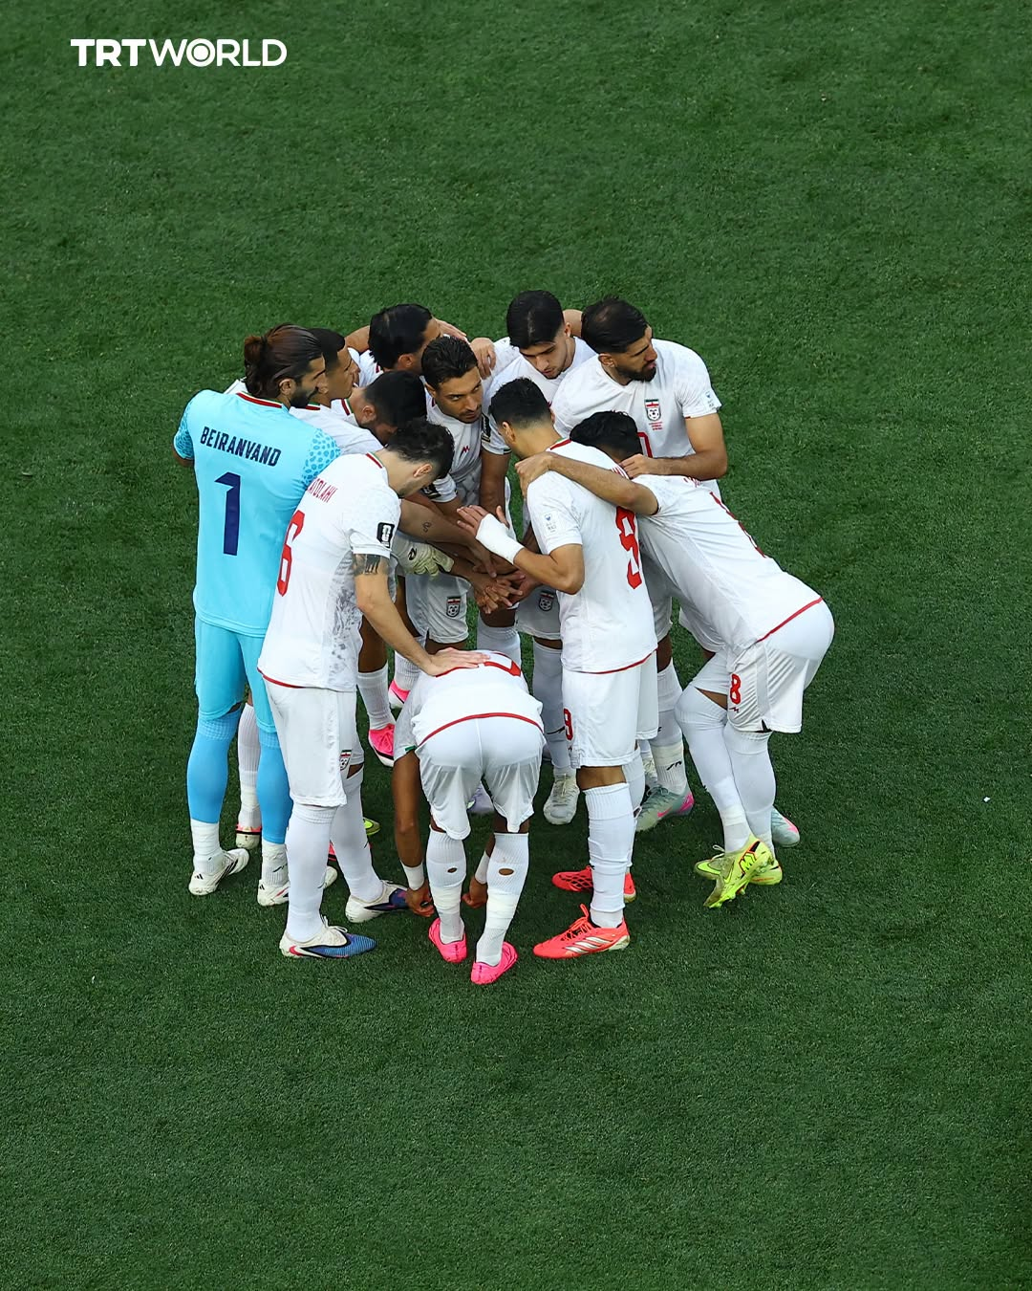
Iran Team huddle at the world cup 2026 @ TRT World

Alireza Beiranvand: From Homelessness to Heroism
The success of any sports team is the sum total of each player. The same was true of the Iranian footballers, who showed incredible resolve in showing up for each game with all their might. But there was one special player who outshone the rest—the goalkeeper, Alireza Beiranvand. His personal story makes his achievement even more extraordinary.

A Humble Beginning in the Mountains
Beiranvand grew up in a nomadic Kurdish Lak family in the mountainous Lorestan Province of western Iran, herding sheep and living in extreme poverty. His father fiercely opposed his dream of playing football, tearing up his clothes and gloves to force him to abandon the sport. Determined to chase his dream, Beiranvand did the unthinkable: he borrowed money from a relative, ran away from home, and travelled to the capital, Tehran.

Surviving on the Streets of Tehran
Once in Tehran, he knew no one and was homeless. He slept on the streets, often outside the gates of local football clubs so he wouldn't miss training. To survive, he took on a series of odd jobs:
- Sweeping streets as a municipal cleaner
- Washing cars at a car wash (once famously washing the SUV of Iranian football legend Ali Daei)
- Working assembly lines in a dressmaking factory
- Preparing dough in a late-night pizza shop

The Breakthrough
His big break came when he joined the youth academy of Naft Tehran, where the coach, aware of his homelessness, allowed him to train and sleep in a prayer room. He worked his way up through the Iranian club system and made his national team debut in 2015. By the 2026 World Cup, Beiranvand had already set two Guinness World Records—for the longest throw and the longest drop-kick in football history.

[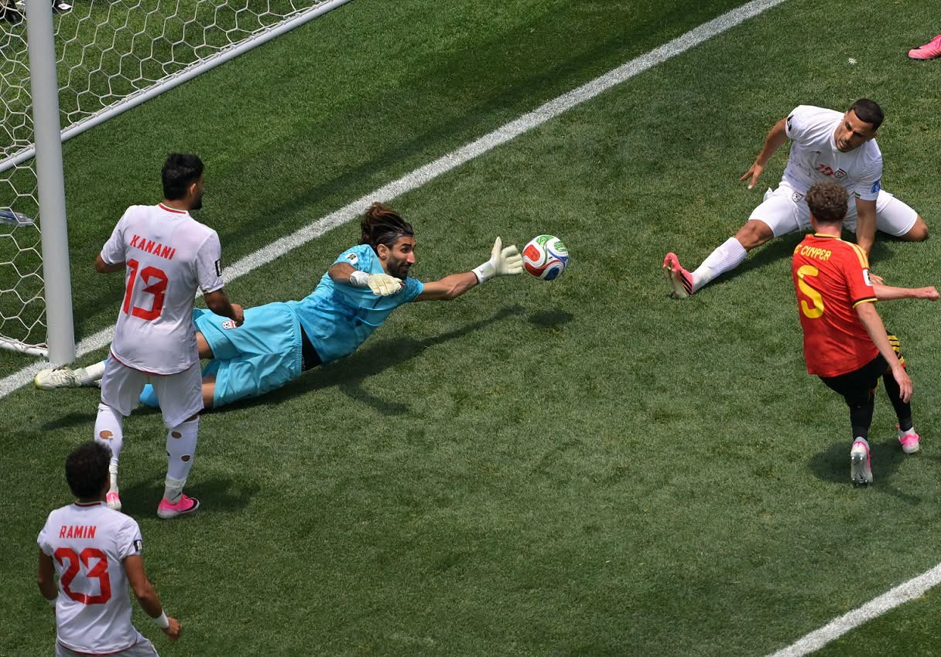
Beiranvand saving the ball. @Football Planet

A Performance for the Ages
In the 2026 World Cup, Beiranvand saved his team from defeat in both of their draws. Against Belgium, he made seven spectacular saves—including a crucial close-range stop in the 86th minute—and was named Player of the Match. He earned the adoration of many around the world and gave his people, the Iranian people, the pride they deserved and needed.

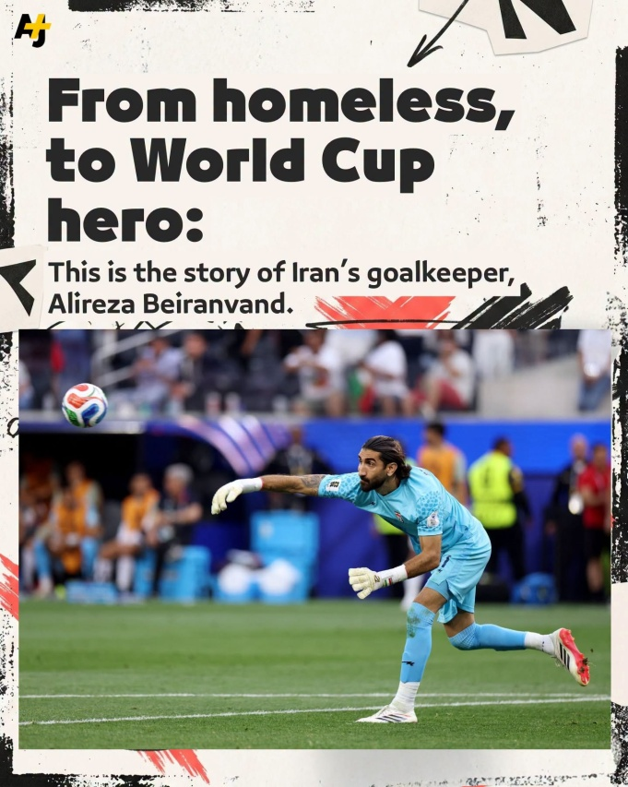
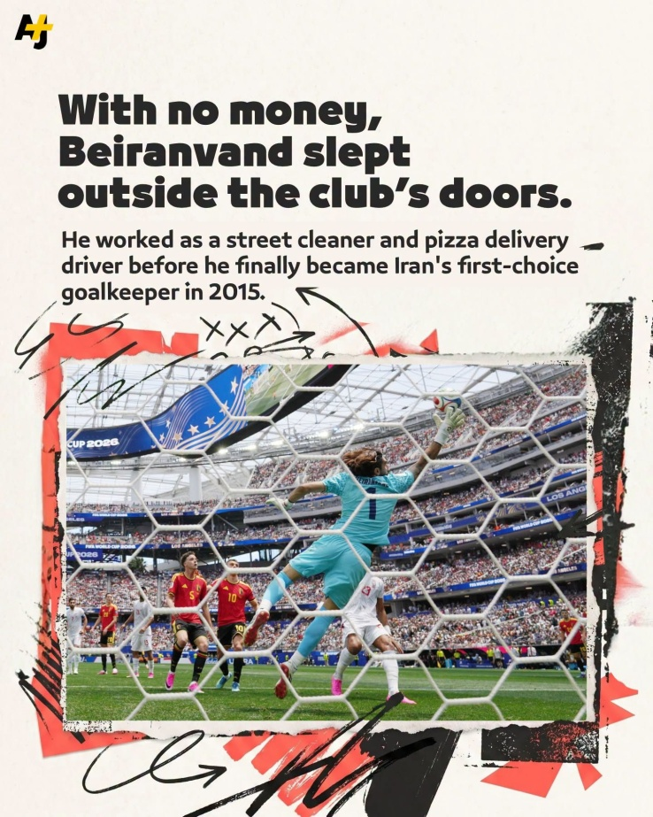
@AJ+ Beiranvand saving the team in World Cup 2026

The Power of the Iranian People Against All Odds
In the midst of a war of aggression by the most powerful nation—the USA—and genocidal Israel, the fact that this team had the audacity and courage to play; shows the power and strength of the Iranian people against all odds. Their resilience on and off the pitch is a testament to the unbreakable spirit of a nation that refuses to be silenced.

